**Custom program report**

Le Hoang MInh-SWH02062,

Introduction

Everyone likes snakes. Even though the game's original concept originates back to 1976, this beloved classic gained popularity when it was included pre-installed on Nokia phones starting in 1998. When I decided to create a snake game using ruby, I searched for several tutorials on the internet. I found the best tutorial from a guy named Mario Visic on youtube. So the credit of my code goes to him

Report

My custom game has 3 main functions

* The snake movement/draw the snake
* The ball spawn
* Game reset/pause/quit

1. The snake movement/draw the snake - class Snake

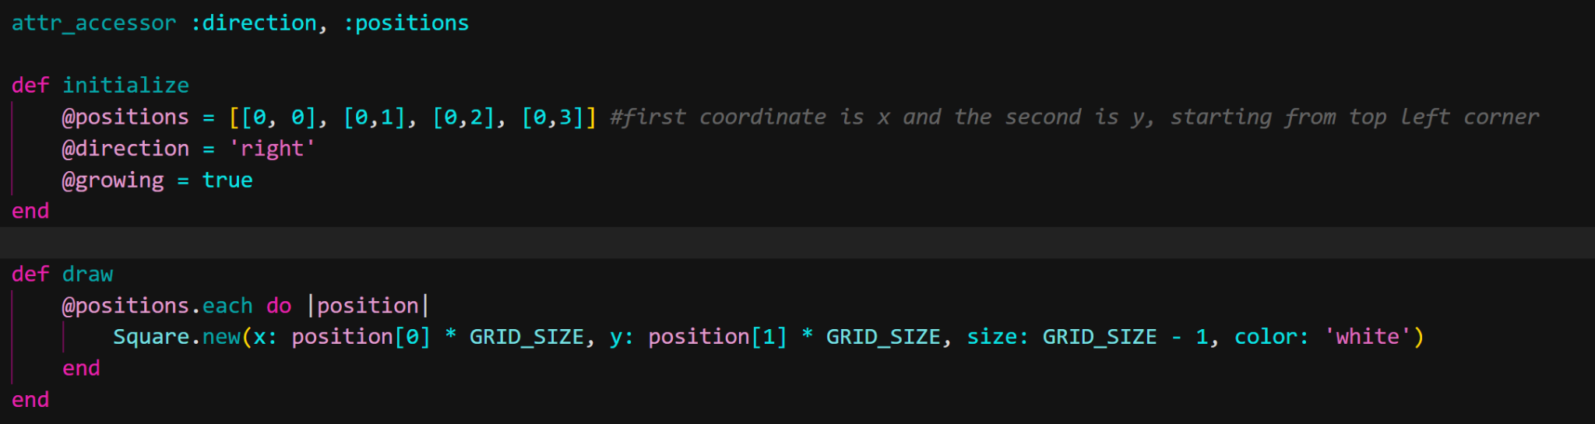

I use the initialize to set up the spawn location of the snake and its direction is right. And initializes a flag growing to true.

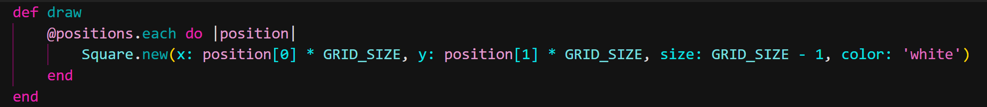

The rendering of the snake on the screen is done by the draw method. It creates squares by using the snake's positions, with each square representing a different section of the snake.

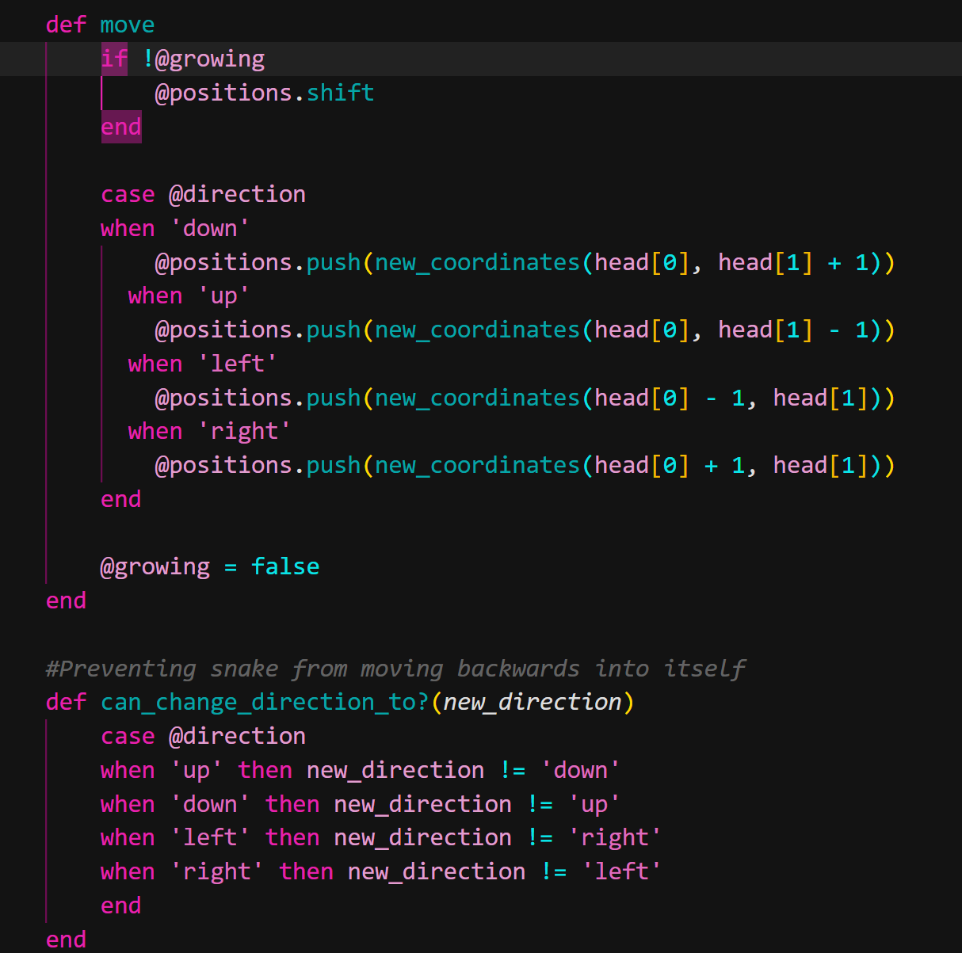

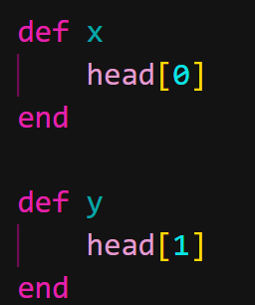The move method updates the position of the snake square. If the snake does not eat the ball, which means it is not in a growing state, then it removes the last square of the snake which is the tail. Next, using the head's coordinates and the direction it is currently facing, it adds a new position to the array. The can_change_direction_to method is used to avoid the snake going backward. The snake's head's x and y coordinates are returned by the x and y methods.



This method is used to check if there are any duplicate positions of the snake. For example the snake head touches its body then there is a duplicate in positions so the game ends.

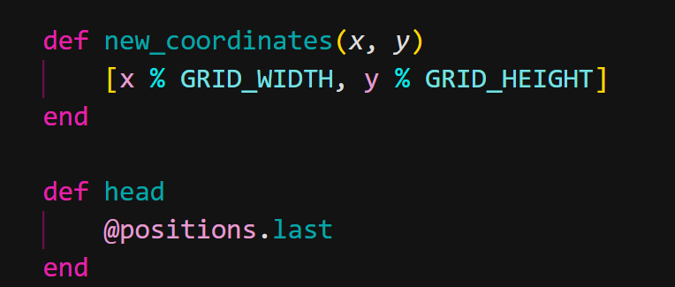the new_coordinates is use to appear the snake across the window screen and the head method use to return the head of the snake

1. The ball spawn

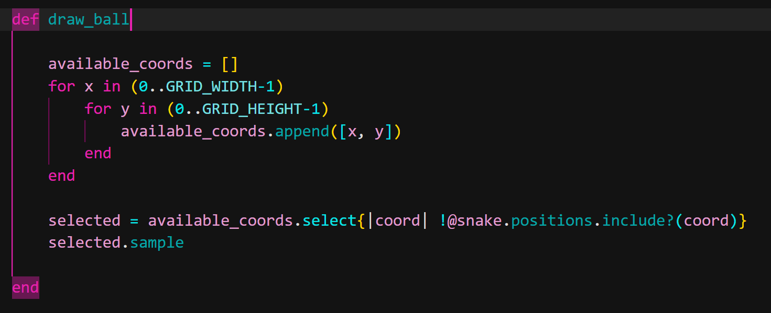

the draw ball will calculate a number of available locations on the window screen then append it to x-coordinates and y-coordinates. The “selected” is use to calculate the spawn coordinates of the ball except the coordinates of the snake.

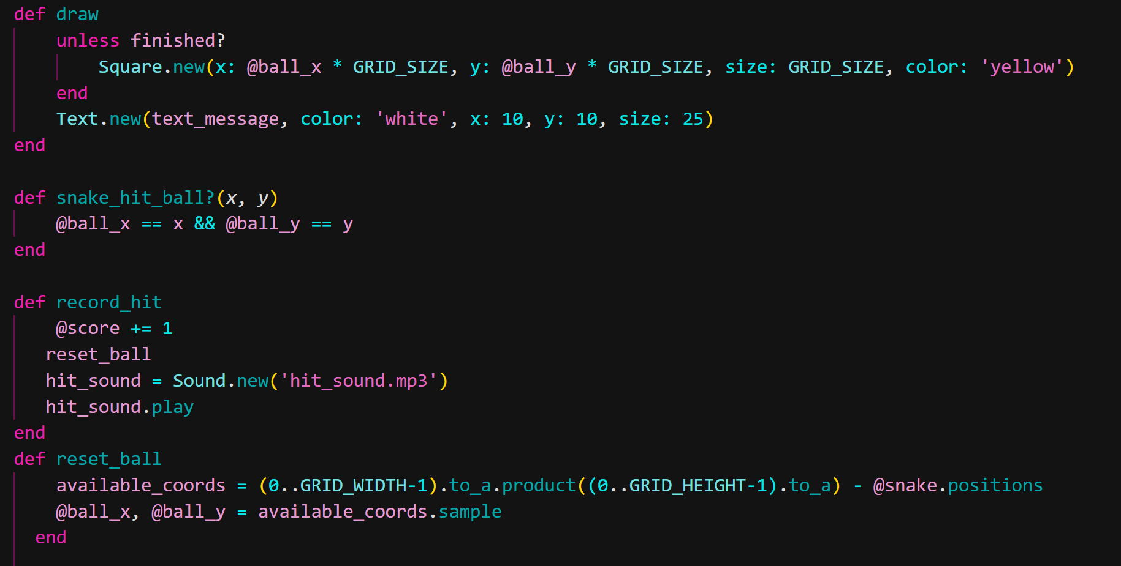

the draw method responsible for the drawing of the ball and the text message. Unless the game is finished, it will draw a yellow ball on the screen and also display the player scores. The snake_hit_ball method takes two parameters x and y to represent a part of the snake. it will check if the ball x and y coordinate are the same with the snake coordinate, which means the snake has eaten the ball. The record_hit method will increase the score by 1 if the snake hits the ball in the previous method then it will play a sound. the reset_ball method will find the available coordinates on the screen expect the snake position and then redraw the ball.

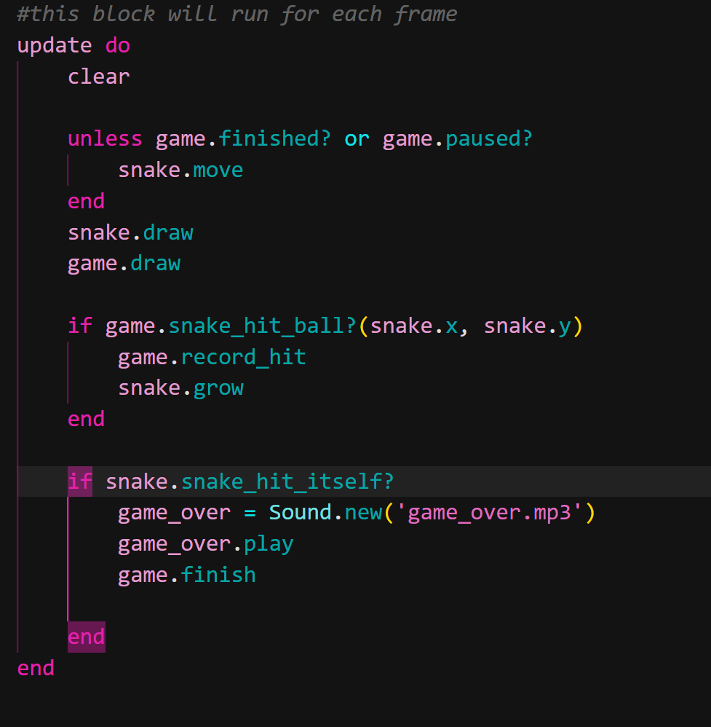

this is the main loop update that will automatically run the whole program

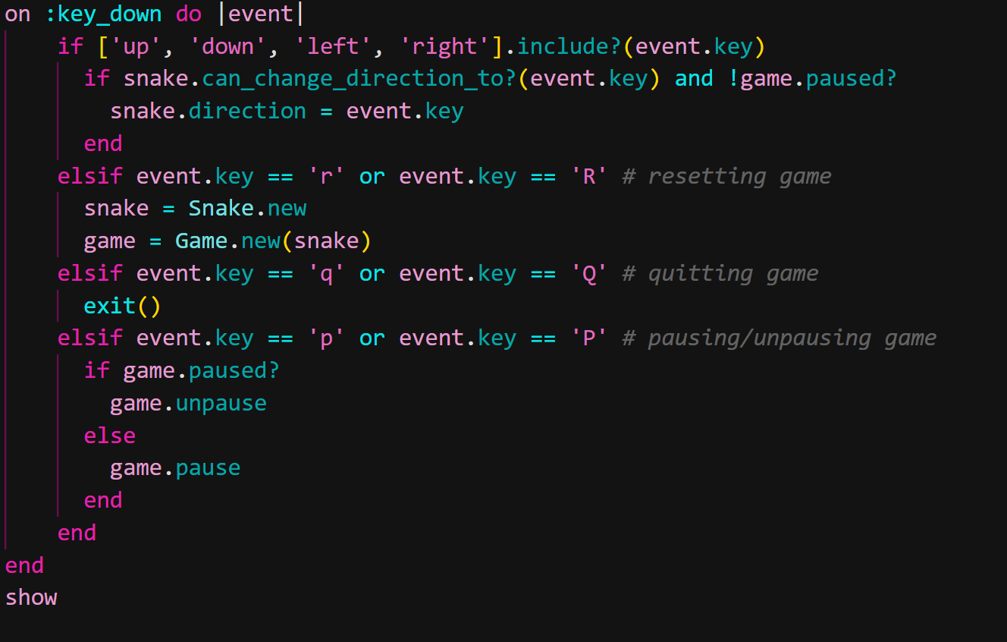

Handles key-down events in this section. It determines which key was pressed and responds accordingly. The game updates the snake's direction if the pressed key is one of the arrow keys ('up, down, left, or right'), and the snake can change direction in response to the pressed key.